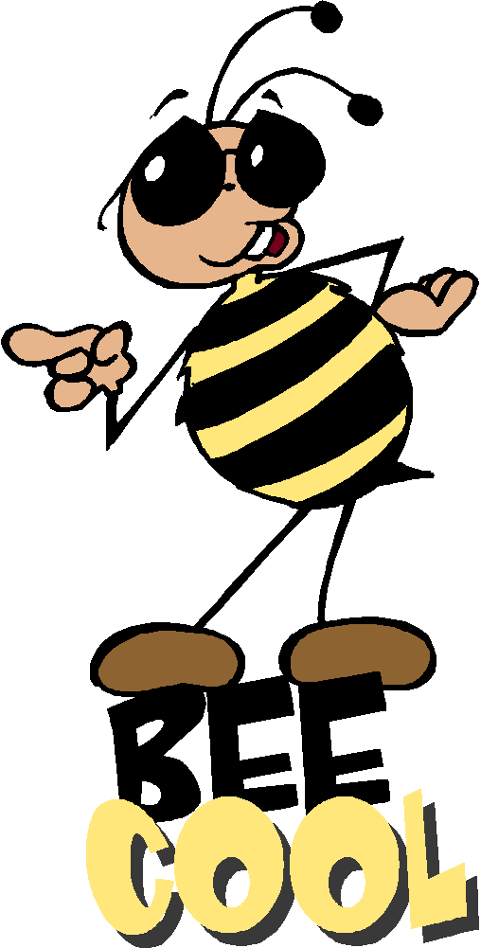
Sort 11 Spelling Words
Short o (CVC) and long o (CVCe and CVVC)

clock note boat love crop stone
float none cross chose coat shop whole toast lock slope soap knock joke toad

Spelling Test Friday on ten of your weekly spelling words, remember to study every night.

Sort 11 Spelling Words
Short o (CVC) and long o (CVCe and CVVC)

clock note boat love crop stone
float none cross chose coat shop whole toast lock slope soap knock joke toad

Spelling Test Friday on ten of your weekly spelling words, remember to study every night.

Sort 11 Spelling Words
Short o (CVC) and long o (CVCe and CVVC)

clock note boat love crop stone
float none cross chose coat shop whole toast lock slope soap knock joke toad

Spelling Test Friday on ten of your weekly spelling words, remember to study every night.

